**Міністерство освіти і науки України**

**Національний технічний університет України**

**«Київський політехнічний інститут імені Ігоря Сікорського»**

**Факультет інформатики та обчислювальної техніки**

**Кафедра обчислювальної техніки**

**Лабораторна робота №4**

з дисципліни

«Об’єктно орієнтоване програмування»

на тему

“Вдосконалення структури коду графічного редактора об’єктів на C++”

Виконав: Перевірив:

Студент групи ІМ-22 Порєв В.М.

Кушнір Микола Миколайович

номер у списку групи: 13

Київ 2023

**Мета**

Отримати вміння та навички проектування класів, виконавши модернізацію коду графічного редактора в об’єктно-орієнтованому стилі для забезпечення зручного додавання нових типів об'єктів.

**Завдання**

**1.** Створити у середовищі MS Visual Studio C++ проект Win32 з ім’ям **Lab4**.

**2.** Написати вихідний текст програми згідно варіанту завдання.

**3.** Скомпілювати вихідний текст і отримати виконуваний файл програми.

**4.** Перевірити роботу програми. Налагодити програму.

**5.** Проаналізувати та прокоментувати результати та вихідний текст програми.

**6.** Оформити звіт.

**Умови завдання за варіантом (Ж = 13):**

* Глобальний статичний об’єкт класу ***MyEditor*** *(13 % 2 ≠ 0)*

**Вихідні тексти файлів програми**

**Lab4.kt**

package com.oop.lab4  
  
import android.os.Bundle  
import androidx.appcompat.app.AppCompatActivity

import com.oop.lab4.shape.Shape  
import com.oop.lab4.my_editor.MyEditor  
import com.oop.lab4.paint_view.PaintView  
import com.oop.lab4.main_toolbar.MainToolbar  
import com.oop.lab4.objects_toolbar.ObjectsToolbar

class Lab4 : AppCompatActivity() {  
 private lateinit var editor: MyEditor  
 private lateinit var mainToolbar: MainToolbar  
 private lateinit var objectsToolbar: ObjectsToolbar

override fun onCreate(savedInstanceState: Bundle?) {  
 super.onCreate(savedInstanceState)  
 setContentView(R.layout.*main_activity*)

editor = MyEditor(this)

mainToolbar = findViewById(R.id.*main_toolbar*)  
 mainToolbar.onCreate(editor)  
 mainToolbar.setObjListeners(::onObjSelect, ::onObjCancel)

objectsToolbar = findViewById(R.id.*objects_toolbar*)  
 objectsToolbar.onCreate(editor)  
 objectsToolbar.setObjListeners(::onObjSelect, ::onObjCancel)

val paintView = findViewById<PaintView>(R.id.*paint_view*)  
 paintView.handler = editor  
 editor.paintUtils = paintView  
 }

private fun onObjSelect(shape: Shape) {  
 mainToolbar.onObjSelect(shape)  
 objectsToolbar.onObjSelect(shape)  
 editor.start(shape)  
 }

private fun onObjCancel() {  
 mainToolbar.onObjCancel()  
 objectsToolbar.onObjCancel()  
 editor.close()  
 }  
}

**PaintUtils.kt**

package com.oop.lab4.paint_view  
  
import android.graphics.Canvas

interface PaintUtils {  
 val drawnShapesCanvas: Canvas  
 val rubberTraceCanvas: Canvas

fun repaint()  
 fun clearCanvas(canvas: Canvas)  
}

**PaintView.kt**

package com.oop.lab4.paint_view  
  
import android.content.Context  
import android.graphics.Bitmap  
import android.graphics.Canvas  
import android.graphics.Color  
import android.graphics.PorterDuff  
import android.util.AttributeSet  
import android.view.MotionEvent  
import android.view.View

import com.oop.lab4.shape_editor.PaintMessagesHandler

class PaintView(context: Context, attrs: AttributeSet?):  
 View(context, attrs),  
 PaintUtils {  
 lateinit var handler: PaintMessagesHandler

override lateinit var drawnShapesCanvas: Canvas  
 override lateinit var rubberTraceCanvas: Canvas

private lateinit var drawnShapesBitmap: Bitmap  
private lateinit var rubberTraceBitmap: Bitmap

override fun onSizeChanged(w: Int, h: Int, oldw: Int, oldh: Int) {  
 super.onSizeChanged(w, h, oldw, oldh)  
 drawnShapesBitmap = Bitmap.createBitmap(w, h, Bitmap.Config.*ARGB_8888*)  
 drawnShapesCanvas = Canvas(drawnShapesBitmap)  
 rubberTraceBitmap = Bitmap.createBitmap(w, h, Bitmap.Config.*ARGB_8888*)  
 rubberTraceCanvas = Canvas(rubberTraceBitmap)  
}

override fun onDraw(canvas: Canvas) {  
 super.onDraw(canvas)  
 if (!handler.isRubberTraceModeOn) {  
 handler.onPaint()  
 canvas.drawBitmap(drawnShapesBitmap!!, 0F, 0F, null)  
 } else {  
 canvas.drawBitmap(drawnShapesBitmap!!, 0F, 0F, null)  
 canvas.drawBitmap(rubberTraceBitmap!!, 0F, 0F, null)  
 }  
 }

override fun onTouchEvent(event: MotionEvent): Boolean {  
 super.onTouchEvent(event)  
 val x = event.*x* val y = event.*y* when (event.*action*) {  
 MotionEvent.*ACTION_DOWN* -> handler.onFingerTouch(x, y)  
 MotionEvent.*ACTION_MOVE* -> handler.onFingerMove(x, y)  
 MotionEvent.*ACTION_UP* -> handler.onFingerRelease()  
 }  
 return true  
 }

override fun repaint() {  
 invalidate()  
 }

override fun clearCanvas(canvas: Canvas) {  
 canvas.drawColor(Color.*TRANSPARENT*, PorterDuff.Mode.*MULTIPLY*)  
 }  
}

**PaintMessagesHandler.kt**

package com.oop.lab4.shape_editor

interface PaintMessagesHandler {  
 var isRubberTraceModeOn: Boolean

fun onFingerTouch(x: Float, y: Float)  
 fun onFingerMove(x: Float, y:Float)  
 fun onFingerRelease()  
 fun onPaint()  
}

**MyEditor.kt**

package com.oop.lab4.my_editor  
  
import android.content.Context  
import com.oop.lab4.paint_view.PaintUtils  
import com.oop.lab4.shape.Shape  
import com.oop.lab4.shape.PointShape  
import com.oop.lab4.shape.LineShape  
import com.oop.lab4.shape.RectShape  
import com.oop.lab4.shape.EllipseShape  
import com.oop.lab4.shape.SegmentShape  
import com.oop.lab4.shape.CuboidShape

class MyEditor(context: Context): PaintMessagesHandler {  
 lateinit var paintUtils: PaintUtils  
 override var isRubberTraceModeOn = false

val shapes = *arrayOf*(  
 PointShape(context),  
 LineShape(context),  
 RectShape(context),  
 EllipseShape(context),  
 SegmentShape(context),  
 CuboidShape(context),  
 )  
 var currentShape: Shape? = null  
 private set  
 private val drawnShapes = *mutableListOf*<Shape>()

fun start(shape: Shape) {  
 currentShape = shape  
 }

fun close() {  
 currentShape = null  
 }

override fun onFingerTouch(x: Float, y: Float) {  
 currentShape?.*apply* **{** setStart(x, y)  
 setEnd(x, y)  
 **}** }  
 override fun onFingerMove(x: Float, y: Float) {  
 currentShape?.*let* **{** isRubberTraceModeOn = true  
 paintUtils.clearCanvas(paintUtils.rubberTraceCanvas)  
 **it**.setEnd(x, y)  
 **it**.showRubberTrace(paintUtils.rubberTraceCanvas)  
 paintUtils.repaint()  
 **}** }

override fun onFingerRelease() {  
 currentShape = currentShape?.*let* **{** isRubberTraceModeOn = false  
 if (**it**.isValid()) {  
 drawnShapes.add(**it**)  
 }  
 paintUtils.repaint()  
 **it**.getInstance()  
 **}** }

override fun onPaint() {  
 paintUtils.clearCanvas(paintUtils.rubberTraceCanvas)  
 paintUtils.clearCanvas(paintUtils.drawnShapesCanvas)  
 drawnShapes.*forEach* **{  
 it**.showDefault(paintUtils.drawnShapesCanvas)  
 **}** }

fun undo() {  
 if (drawnShapes.size > 0) {  
 drawnShapes.*removeLast*()  
 paintUtils.repaint()  
 }  
 }

fun clearAll() {  
 if (drawnShapes.size > 0) {  
 drawnShapes.clear()  
 paintUtils.repaint()  
 }  
 }  
}

**Shape.kt**

package com.oop.lab4.shape  
  
import android.content.Context  
import android.graphics.Canvas

import android.graphics.DashPathEffect  
import android.graphics.Paint  
import com.oop.lab4.R

abstract class Shape(private val context: Context) {  
 abstract val name: String  
 val associatedIds = *mutableMapOf*<String, Int>()

protected var startX: Float = 0F  
 protected var startY: Float = 0F  
 protected var endX: Float = 0F  
 protected var endY: Float = 0F

fun setStart(x: Float, y: Float) {  
 startX = x  
 startY = y  
 }

fun setEnd(x: Float, y: Float) {  
 endX = x  
 endY = y  
 }

abstract fun isValid(): Boolean

abstract fun getInstance(): Shape

protected open fun getOutlinePaint(): Paint {  
 return Paint().*apply* **{** *isAntiAlias* = true  
 *style* = Paint.Style.*STROKE  
 strokeWidth* = 7F  
 *color* = context.getColor(R.color.*black*)  
 **}** }

protected open fun getFillingPaint(): Paint {  
 return Paint().*apply* **{** *isAntiAlias* = true  
 *style* = Paint.Style.*FILL* **}** }

protected open fun getRubberTracePaint(): Paint {  
 val paint = getOutlinePaint()  
 paint.*color* = context.getColor(R.color.*dark_blue*)  
 val dashLen = 30F  
 val spaceLen = 15F  
 val dashDensity = *floatArrayOf*(dashLen, spaceLen, dashLen, spaceLen)  
 paint.*pathEffect* = DashPathEffect(dashDensity, 0F)  
 return paint  
 }

abstract fun show(canvas: Canvas, outlinePaint: Paint, fillingPaint: Paint?)

abstract fun showDefault(canvas: Canvas)

fun showRubberTrace(canvas: Canvas) {  
 show(canvas, getRubberTracePaint(), null)  
 }  
}

**PointShape.kt**

package com.oop.lab4.shape  
  
import android.content.Context  
import android.graphics.Canvas  
import android.graphics.Paint  
import com.oop.lab4.R

class PointShape(private val context: Context): Shape(context) {  
 override val name = context.getString(R.string.*point*)

override fun isValid(): Boolean {  
 return true  
 }

override fun getInstance(): Shape {  
 return PointShape(context, editor).*also* **{  
 it**.associatedIds.putAll(this.associatedIds)  
 **}** }

override fun getOutlinePaint(): Paint {  
 return super.getOutlinePaint().*apply* **{** *strokeWidth* = 15F  
 **}** }  
 override fun getRubberTracePaint(): Paint {  
 return super.getRubberTracePaint().*apply* **{** *strokeWidth* = 15F  
 **}** }

override fun show(canvas: Canvas, outlinePaint: Paint, fillingPaint: Paint?) {  
 canvas.drawPoint(startX, startY, outlinePaint)  
 }

override fun showDefault(canvas: Canvas) {  
 show(canvas, getOutlinePaint(), null)  
 }  
}

**LineShape.kt**

package com.oop.lab4.shape  
  
import android.content.Context  
import android.graphics.Canvas  
import android.graphics.Paint  
import com.oop.lab4.R

class LineShape(private val context: Context): Shape(context) {  
 override val name = context.getString(R.string.*line*)

override fun isValid(): Boolean {  
 return (startX != endX || startY != endY)  
 }

override fun getInstance(): Shape {  
 return LineShape(context, editor).*also* **{  
 it**.associatedIds.putAll(this.associatedIds)  
 **}** }

override fun show(canvas: Canvas, outlinePaint: Paint, fillingPaint: Paint?) {  
 canvas.drawLine(startX, startY, endX, endY, outlinePaint)  
 }

override fun showDefault(canvas: Canvas) {  
 show(canvas, getOutlinePaint(), null)  
 }  
}

**RectShape.kt**

package com.oop.lab4.shape  
  
import android.content.Context  
import android.graphics.Canvas  
import android.graphics.Paint  
import android.graphics.RectF  
import com.oop.lab4.R

class RectShape(private val context: Context): Shape(context) {  
 override val name = context.getString(R.string.*rectangle*)

override fun isValid(): Boolean {  
 return (startX != endX || startY != endY)  
 }

override fun getInstance(): Shape {  
 return RectShape(context, editor).*also* **{  
 it**.associatedIds.putAll(this.associatedIds)  
 **}** }

override fun show(canvas: Canvas, outlinePaint: Paint, fillingPaint: Paint?) {  
 val rect = RectF(startX, startY, endX, endY)  
 fillingPaint?.*let* **{** canvas.drawRect(rect, **it**)  
 **}** canvas.drawRect(rect, outlinePaint)  
 }

override fun showDefault(canvas: Canvas) {  
 show(canvas, getOutlinePaint(), null)  
 }  
}

**EllipseShape.kt**

package com.oop.lab4.shape  
  
import android.content.Context  
import android.graphics.Canvas  
import android.graphics.Paint  
import android.graphics.RectF  
import com.oop.lab4.R

class EllipseShape(private val context: Context): Shape(context) {  
 override val name = context.getString(R.string.*ellipse*)

override fun isValid(): Boolean {  
 return (startX != endX || startY != endY)  
 }

override fun getInstance(): Shape {  
 return EllipseShape(context, editor).*also* **{  
 it**.associatedIds.putAll(this.associatedIds)  
 **}** }

override fun getFillingPaint(): Paint {  
 return super.getFillingPaint().*apply* **{** *color* = context.getColor(R.color.*light_green*)  
 **}** }

override fun show(canvas: Canvas, outlinePaint: Paint, fillingPaint: Paint?) {  
 val dx = endX - startX  
 val dy = endY - startY  
 val rect = RectF(startX - dx, startY - dy, endX, endY).*apply* **{** sort() **}**  fillingPaint?.*let* **{**  canvas.drawOval(rect, **it**)  
 **}**  canvas.drawOval(rect, outlinePaint)  
 }

override fun showDefault(canvas: Canvas) {  
 show(canvas, getOutlinePaint(), getFillingPaint())  
 }  
}

**LineShapeInterface.kt**

package com.oop.lab4.shape  
  
import android.content.Context  
import android.graphics.Canvas  
import android.graphics.Paint  
import android.graphics.PointF

interface LineShapeInterface {  
 fun lineShapeShow(context: Context, canvas: Canvas, paint: Paint,  
 startPoint: PointF, endPoint: PointF) {  
 val lineShape = LineShape(context)  
 lineShape.setStart(startPoint.x, startPoint.y)  
 lineShape.setEnd(endPoint.x, endPoint.y)  
 lineShape.show(canvas, paint, null)  
 }  
}

**RectShapeInterface.kt**

package com.oop.lab4.shape  
  
import android.content.Context  
import android.graphics.Canvas  
import android.graphics.Paint  
import android.graphics.RectF

interface RectShapeInterface {  
 fun rectShapeShow(context: Context, canvas: Canvas,  
 outlinePaint: Paint, fillingPaint: Paint?,  
 rect: RectF) {  
 val rectShape = RectShape(context)  
 rectShape.setStart(rect.left, rect.top)  
 rectShape.setEnd(rect.right, rect.bottom)  
 rectShape.show(canvas, outlinePaint, fillingPaint)  
 }  
}

**EllipseShapeInterface.kt**

package com.oop.lab4.shape  
  
import android.content.Context  
import android.graphics.Canvas  
import android.graphics.Paint  
import android.graphics.PointF

interface EllipseShapeInterface {  
 fun ellipseShapeShow(context: Context, canvas: Canvas,  
 outlinePaint: Paint, fillingPaint: Paint?,  
 centerPoint: PointF, radius: Float) {  
 val ellipseShape = EllipseShape(context)  
 ellipseShape.setStart(centerPoint.x, centerPoint.y)  
 ellipseShape.setEnd(centerPoint.x + radius, centerPoint.y + radius)  
 ellipseShape.show(canvas, outlinePaint, fillingPaint)  
 }  
}

**SegmentShape.kt**

package com.oop.lab4.shape  
  
import android.content.Context  
import android.graphics.Canvas  
import android.graphics.Paint  
import android.graphics.PointF  
import com.oop.lab4.R  
import kotlin.math.abs  
import kotlin.math.acos  
import kotlin.math.cos  
import kotlin.math.sin  
import kotlin.math.sqrt  
  
class SegmentShape(private val context: Context):  
 Shape(context),  
 LineShapeInterface,  
 EllipseShapeInterface {  
 override val name = context.getString(R.string.*segment*)

override fun isValid(): Boolean {  
 return (startX != endX || startY != endY)  
 }

override fun getInstance(): Shape {  
 return SegmentShape(context).*also* **{  
 it**.associatedIds.putAll(this.associatedIds)  
 **}** }

override fun show(canvas: Canvas, outlinePaint: Paint, fillingPaint: Paint?) {  
 if (!isValid()) {  
 return  
 }  
 val ellipseRadius = 50F  
 val startEllipseCenter = PointF(startX, startY)  
 val endEllipseCenter = PointF(endX, endY)

val dx = *abs*(endX - startX)  
 val dy = *abs*(endY - startY)  
 val distance = *sqrt*(dx * dx + dy * dy)  
 val angle = *acos*(dx / distance)  
 val offset = PointF(ellipseRadius * *cos*(angle), ellipseRadius * *sin*(angle))

val startTangentPoint = PointF()  
 val endTangentPoint = PointF()  
 if (startX < endX) {  
 startTangentPoint.x = startX + offset.x  
 endTangentPoint.x = endX - offset.x  
 } else {  
 startTangentPoint.x = startX - offset.x  
 endTangentPoint.x = endX + offset.x  
 }  
 if (startY < endY) {  
 startTangentPoint.y = startY + offset.y  
 endTangentPoint.y = endY - offset.y  
 } else {  
 startTangentPoint.y = startY - offset.y  
 endTangentPoint.y = endY + offset.y  
 }  
 lineShapeShow(context, canvas, outlinePaint, startTangentPoint, endTangentPoint)  
 ellipseShapeShow(context, canvas, outlinePaint, null,  
 startEllipseCenter, ellipseRadius)  
 ellipseShapeShow(context, canvas, outlinePaint, null,  
 endEllipseCenter, ellipseRadius)  
 }

override fun showDefault(canvas: Canvas) {  
 show(canvas, getOutlinePaint(), null)  
 }  
}

**CuboidShape.kt**

package com.oop.lab4.shape  
  
import android.content.Context  
import android.graphics.Canvas  
import android.graphics.Paint  
import android.graphics.PointF  
import android.graphics.RectF  
import com.oop.lab4.R

class CuboidShape(private val context: Context):  
 Shape(context),  
 LineShapeInterface,  
 RectShapeInterface {  
 override val name = context.getString(R.string.*cuboid*)

override fun isValid(): Boolean {  
 return (startX != endX || startY != endY)  
 }  
 override fun getInstance(): Shape {  
 return CuboidShape(context).*also* **{  
 it**.associatedIds.putAll(this.associatedIds)  
 **}** }

override fun show(canvas: Canvas, outlinePaint: Paint, fillingPaint: Paint?) {  
 val frontRect = RectF(startX, startY, endX, endY)  
 rectShapeShow(context, canvas, outlinePaint, null, frontRect)  
 val offset = 100F  
 val backRect = RectF(frontRect).*apply* **{** offset(offset, -offset)  
 **}** rectShapeShow(context, canvas, outlinePaint, null, backRect)  
 frontRect.sort()  
 backRect.sort()  
 lineShapeShow(context, canvas, outlinePaint,  
 PointF(frontRect.right, frontRect.top),  
 PointF(backRect.right, backRect.top)  
 )  
 lineShapeShow(context, canvas, outlinePaint,  
 PointF(frontRect.right, frontRect.bottom),  
 PointF(backRect.right, backRect.bottom)  
 )  
 lineShapeShow(context, canvas, outlinePaint,  
 PointF(frontRect.left, frontRect.bottom),  
 PointF(backRect.left, backRect.bottom)  
 )  
 lineShapeShow(context, canvas, outlinePaint,  
 PointF(frontRect.left, frontRect.top),  
 PointF(backRect.left, backRect.top)  
 )  
 }

override fun showDefault(canvas: Canvas) {  
 show(canvas, getOutlinePaint(), null)  
 }  
}

**MainToolbar.kt**

package com.oop.lab4.main_toolbar  
  
import android.content.Context  
import android.util.AttributeSet  
import android.view.MenuItem  
import android.view.View  
import android.widget.ImageButton  
import android.widget.PopupMenu  
import android.widget.TextView  
import androidx.appcompat.widget.Toolbar  
import com.oop.lab4.R

import com.oop.lab4.my_editor.MyEditor  
import com.oop.lab4.shape.Shape  
import com.oop.lab4.tooltip.Tooltip

class MainToolbar(context: Context, attrs: AttributeSet?):  
 Toolbar(context, attrs) {  
 private lateinit var optionsMenu: PopupMenu  
 private lateinit var fileSubmenu: PopupMenu  
 private lateinit var objSubmenu: PopupMenu

private lateinit var editor: MyEditor  
 private lateinit var objSubmenuItems: Array<MenuItem>

private lateinit var onObjSelectListener: (Shape) -> Unit  
 private lateinit var onObjCancelListener: () -> Unit

private lateinit var currentObjTextView: TextView

fun onCreate(editor: MyEditor) {  
 val btnOptions = findViewById<ImageButton>(R.id.*btn_options*)  
 btnOptions.setOnClickListener **{** optionsMenu.show()  
 **}** optionsMenu = createOptionsMenu(btnOptions)  
 fileSubmenu = createFileSubmenu(btnOptions)  
 objSubmenu = createObjSubmenu(btnOptions)  
 this.editor = editor  
 objSubmenuItems = *arrayOf*(  
 objSubmenu.*menu*.findItem(R.id.*item_point*),  
 objSubmenu.*menu*.findItem(R.id.*item_line*),  
 objSubmenu.*menu*.findItem(R.id.*item_rectangle*),  
 objSubmenu.*menu*.findItem(R.id.*item_ellipse*),  
 objSubmenu.*menu*.findItem(R.id.*item_segment*),  
 objSubmenu.*menu*.findItem(R.id.*item_cuboid*),  
 )  
 for (index in objSubmenuItems.*indices*) {  
 val shape = editor.shapes[index]  
 val item = objSubmenuItems[index]  
 shape.associatedIds["objSubmenuItem"] = item.*itemId* }  
 currentObjTextView = findViewById(R.id.*current_object*)  
 }

private fun createOptionsMenu(anchor: View): PopupMenu {  
 val popupMenu = PopupMenu(*context*, anchor)  
 popupMenu.*menuInflater*.inflate(R.menu.*main_toolbar_options_menu*, popupMenu.*menu*)  
 popupMenu.setOnMenuItemClickListener **{** item **->** when(item.*itemId*) {  
 R.id.*file* -> {  
 fileSubmenu.show()  
 true  
 }  
 R.id.*objects* -> {  
 objSubmenu.show()  
 true  
 }  
 R.id.*info* -> {  
 val tooltip = Tooltip(*context*, attrs = null)  
 val text = "Ви натиснули кнопку\n\"Довідка\""  
 tooltip.create(this, text).show()  
 true  
 }  
 else -> {  
 false  
 }  
 }  
 **}** return popupMenu  
 }

private fun createFileSubmenu(anchor: View): PopupMenu {  
 val popupMenu = PopupMenu(*context*, anchor)  
 popupMenu.*menuInflater*.inflate(R.menu.*main_toolbar_file_submenu*, popupMenu.*menu*)  
 popupMenu.setOnMenuItemClickListener **{** item **->** when(item.*itemId*) {  
 R.id.*undo* -> {  
 editor.undo()  
 true  
 }  
 R.id.*clear_all* -> {  
 editor.clearAll()  
 true  
 }  
 else -> {  
 false  
 }  
 }  
 **}** return popupMenu  
 }

private fun createObjSubmenu(anchor: View): PopupMenu {  
 val popupMenu = PopupMenu(*context*, anchor)  
 popupMenu.*menuInflater*.inflate(R.menu.*main_toolbar_objects_submenu*, popupMenu.*menu*)  
 popupMenu.setOnMenuItemClickListener **{** clickedItem **->** for (index in objSubmenuItems.*indices*) {  
 val item = objSubmenuItems[index]  
 if (item == clickedItem) {  
 if (!item.*isChecked*) {  
 val shape = editor.shapes[index]  
 onObjSelectListener(shape.getInstance())  
 } else {  
 onObjCancelListener()  
 }  
 }  
 }  
 true  
 **}** return popupMenu  
 }

fun setObjListeners(  
 onSelectListener: (Shape) -> Unit,  
 onCancelListener: () -> Unit  
 ) {  
 onObjSelectListener = onSelectListener  
 onObjCancelListener = onCancelListener  
 }

fun onObjSelect(shape: Shape) {  
 currentObjTextView.*text* = shape.name  
 editor.currentShape?.*let* **{** val id = **it**.associatedIds["objSubmenuItem"]  
 val item = objSubmenu.*menu*.findItem(id!!)  
 item.*isChecked* = false  
 **}** val id = shape.associatedIds["objSubmenuItem"]  
 val item = objSubmenu.*menu*.findItem(id!!)  
 item.*isChecked* = true  
 }

fun onObjCancel() {  
 currentObjTextView.*text* = "Не вибрано"  
 editor.currentShape?.*let* **{** val id = **it**.associatedIds["objSubmenuItem"]  
 val item = objSubmenu.*menu*.findItem(id!!)  
 item.*isChecked* = false  
 **}** }  
}

**ObjectsToolbar.kt**

package com.oop.lab4.objects_toolbar  
  
import android.content.Context  
import android.util.AttributeSet  
import androidx.appcompat.widget.Toolbar  
import com.oop.lab4.R

import com.oop.lab4.my_editor.MyEditor  
import com.oop.lab4.shape.Shape

class ObjectsToolbar(context: Context, attrs: AttributeSet?):  
 Toolbar(context, attrs) {  
 private lateinit var editor: MyEditor  
 private lateinit var objButtons: Array<ObjectButton>

private lateinit var onObjSelectListener: (Shape) -> Unit  
 private lateinit var onObjCancelListener: () -> Unit

fun onCreate(editor: MyEditor) {  
 this.editor = editor  
 objButtons = *arrayOf*(  
 findViewById(R.id.*btn_point*),  
 findViewById(R.id.*btn_line*),  
 findViewById(R.id.*btn_rectangle*),  
 findViewById(R.id.*btn_ellipse*),  
 findViewById(R.id.*btn_segment*),  
 findViewById(R.id.*btn_cuboid*),  
 )  
 for (index in objButtons.*indices*) {  
 val shape = editor.shapes[index]  
 val button = objButtons[index]  
 shape.associatedIds["objButton"] = button.*id* }  
 }

fun setObjListeners(  
 onSelectListener: (Shape) -> Unit,  
 onCancelListener: () -> Unit  
 ) {  
 onObjSelectListener = onSelectListener  
 onObjCancelListener = onCancelListener  
  
 for (index in objButtons.*indices*) {  
 val button = objButtons[index]  
 val shape = editor.shapes[index]  
 button.onCreate(shape)  
 button.setObjListeners(onObjSelectListener, onObjCancelListener)  
 }  
 }

fun onObjSelect(shape: Shape) {  
 editor.currentShape?.*let* **{** val id = **it**.associatedIds["objButton"]  
 val button = findViewById<ObjectButton>(id!!)  
 button.onObjCancel()  
 **}** val id = shape.associatedIds["objButton"]  
 val button = findViewById<ObjectButton>(id!!)  
 button.onObjSelect()  
 }

fun onObjCancel() {  
 editor.currentShape?.*let* **{** val id = **it**.associatedIds["objButton"]  
 val button = findViewById<ObjectButton>(id!!)  
 button.onObjCancel()  
 **}** }  
}

**ObjectButton.kt**

package com.oop.lab4.objects_toolbar  
  
import android.content.Context  
import android.graphics.PorterDuff  
import android.graphics.PorterDuffColorFilter  
import android.util.AttributeSet  
import android.view.MotionEvent  
import com.oop.lab4.R

import com.oop.lab4.shape.Shape  
import com.oop.lab4.tooltip.Tooltip

class ObjectButton(context: Context, attrs: AttributeSet?):  
 androidx.appcompat.widget.AppCompatImageButton(context, attrs) {  
 private lateinit var shape: Shape

private var isObjSelected = false  
 private lateinit var onObjSelectListener: (Shape) -> Unit  
 private lateinit var onObjCancelListener: () -> Unit

private val selectTooltip = Tooltip(context, attrs)  
 private val cancelTooltip = Tooltip(context, attrs)

private val timeOfLongPress = 1000  
 private var pressStartTime: Long = 0  
 private var pressEndTime: Long = 0

fun onCreate(shape: Shape) {  
 this.shape = shape  
 val selectTooltipText = "Вибрати об\'єкт\n\"${shape.name}\""  
 selectTooltip.create(this, selectTooltipText)  
 val cancelTooltipText = "Вимкнути режим\nредагування"  
 cancelTooltip.create(this, cancelTooltipText)  
 }

override fun onTouchEvent(event: MotionEvent): Boolean {  
 when (event.*action*) {  
 MotionEvent.*ACTION_DOWN* -> {  
 markPressed()  
 pressStartTime = System.currentTimeMillis()  
 }  
 MotionEvent.*ACTION_UP* -> {  
 pressEndTime = System.currentTimeMillis()  
 val pressDuration = pressEndTime - pressStartTime  
 if (pressDuration < timeOfLongPress) {  
 performClick()  
 } else {  
 performLongClick()  
 }  
 pressStartTime = 0  
 pressEndTime = 0  
 }  
 }  
 return true  
 }

override fun performClick(): Boolean {  
 super.performClick()  
 if (!isObjSelected) {  
 onObjSelectListener(shape.getInstance())  
 } else {  
 onObjCancelListener()  
 }  
 return true  
 }

override fun performLongClick(): Boolean {  
 super.performLongClick()  
 if (!isObjSelected) {  
 markNotPressed()  
 selectTooltip.show()  
 } else {  
 markSelected()  
 cancelTooltip.show()  
 }  
 return true  
 }

private fun markPressed() {  
 val backgroundColorId = R.color.*pressed_btn_background_color  
 backgroundTintList* = *context*.getColorStateList(backgroundColorId)  
 }

private fun markNotPressed() {  
 val backgroundColorId = R.color.*transparent  
 backgroundTintList* = *context*.getColorStateList(backgroundColorId)  
 }

private fun markSelected() {  
 val backgroundColorId = R.color.*selected_btn_background_color  
 backgroundTintList* = *context*.getColorStateList(backgroundColorId)  
 val iconColor = *context*.getColor(R.color.*selected_btn_icon_color*)  
 *colorFilter* = PorterDuffColorFilter(iconColor, PorterDuff.Mode.*SRC_IN*)  
 }

private fun markNotSelected() {  
 val backgroundColorId = R.color.*transparent  
 backgroundTintList* = *context*.getColorStateList(backgroundColorId)  
 val iconColor = *context*.getColor(R.color.*on_objects_toolbar_color*)  
 *colorFilter* = PorterDuffColorFilter(iconColor, PorterDuff.Mode.*SRC_IN*)  
 }

fun setObjListeners(  
 onSelectListener: (Shape) -> Unit,  
 onCancelListener: () -> Unit  
 ) {  
 onObjSelectListener = onSelectListener  
 onObjCancelListener = onCancelListener  
 }

fun onObjSelect() {  
 isObjSelected = true  
 markSelected()  
 }

fun onObjCancel() {  
 isObjSelected = false  
 markNotSelected()  
 }  
}

**Tooltip.kt**

package com.oop.lab4.tooltip  
  
import android.content.Context  
import android.util.AttributeSet  
import android.view.View  
import android.widget.Button  
import android.widget.TextView  
import com.google.android.material.snackbar.Snackbar  
import com.oop.lab4.R

class Tooltip(context: Context, attrs: AttributeSet?): View(context, attrs) {  
 private lateinit var tooltip: Snackbar

fun create(parent: View, text: String): Tooltip {  
 val displayDuration = Snackbar.*LENGTH_LONG* tooltip = Snackbar.make(parent, "", displayDuration)

val backgroundColor = *context*.getColor(R.color.*transparent*)  
 tooltip.*view*.setBackgroundColor(backgroundColor)

val layout = tooltip.*view* as Snackbar.SnackbarLayout  
 val view = inflate(*context*, R.layout.*tooltip*, null)  
 layout.addView(view)

val textView = view.findViewById<TextView>(R.id.*tooltip_text*)  
 textView.*text* = text  
  
 val btnHide = view.findViewById<Button>(R.id.*tooltip_hide*)  
 btnHide.setOnClickListener **{** val textColor = *context*.getColor(R.color.*tooltip_bnt_clicked_text_color*)  
 btnHide.setTextColor(textColor)  
 hide()  
 **}** return this  
 }

fun hide() {  
 tooltip.dismiss()  
 }

fun show() {  
 tooltip.show()  
 }  
}

**Діаграма класів програми**

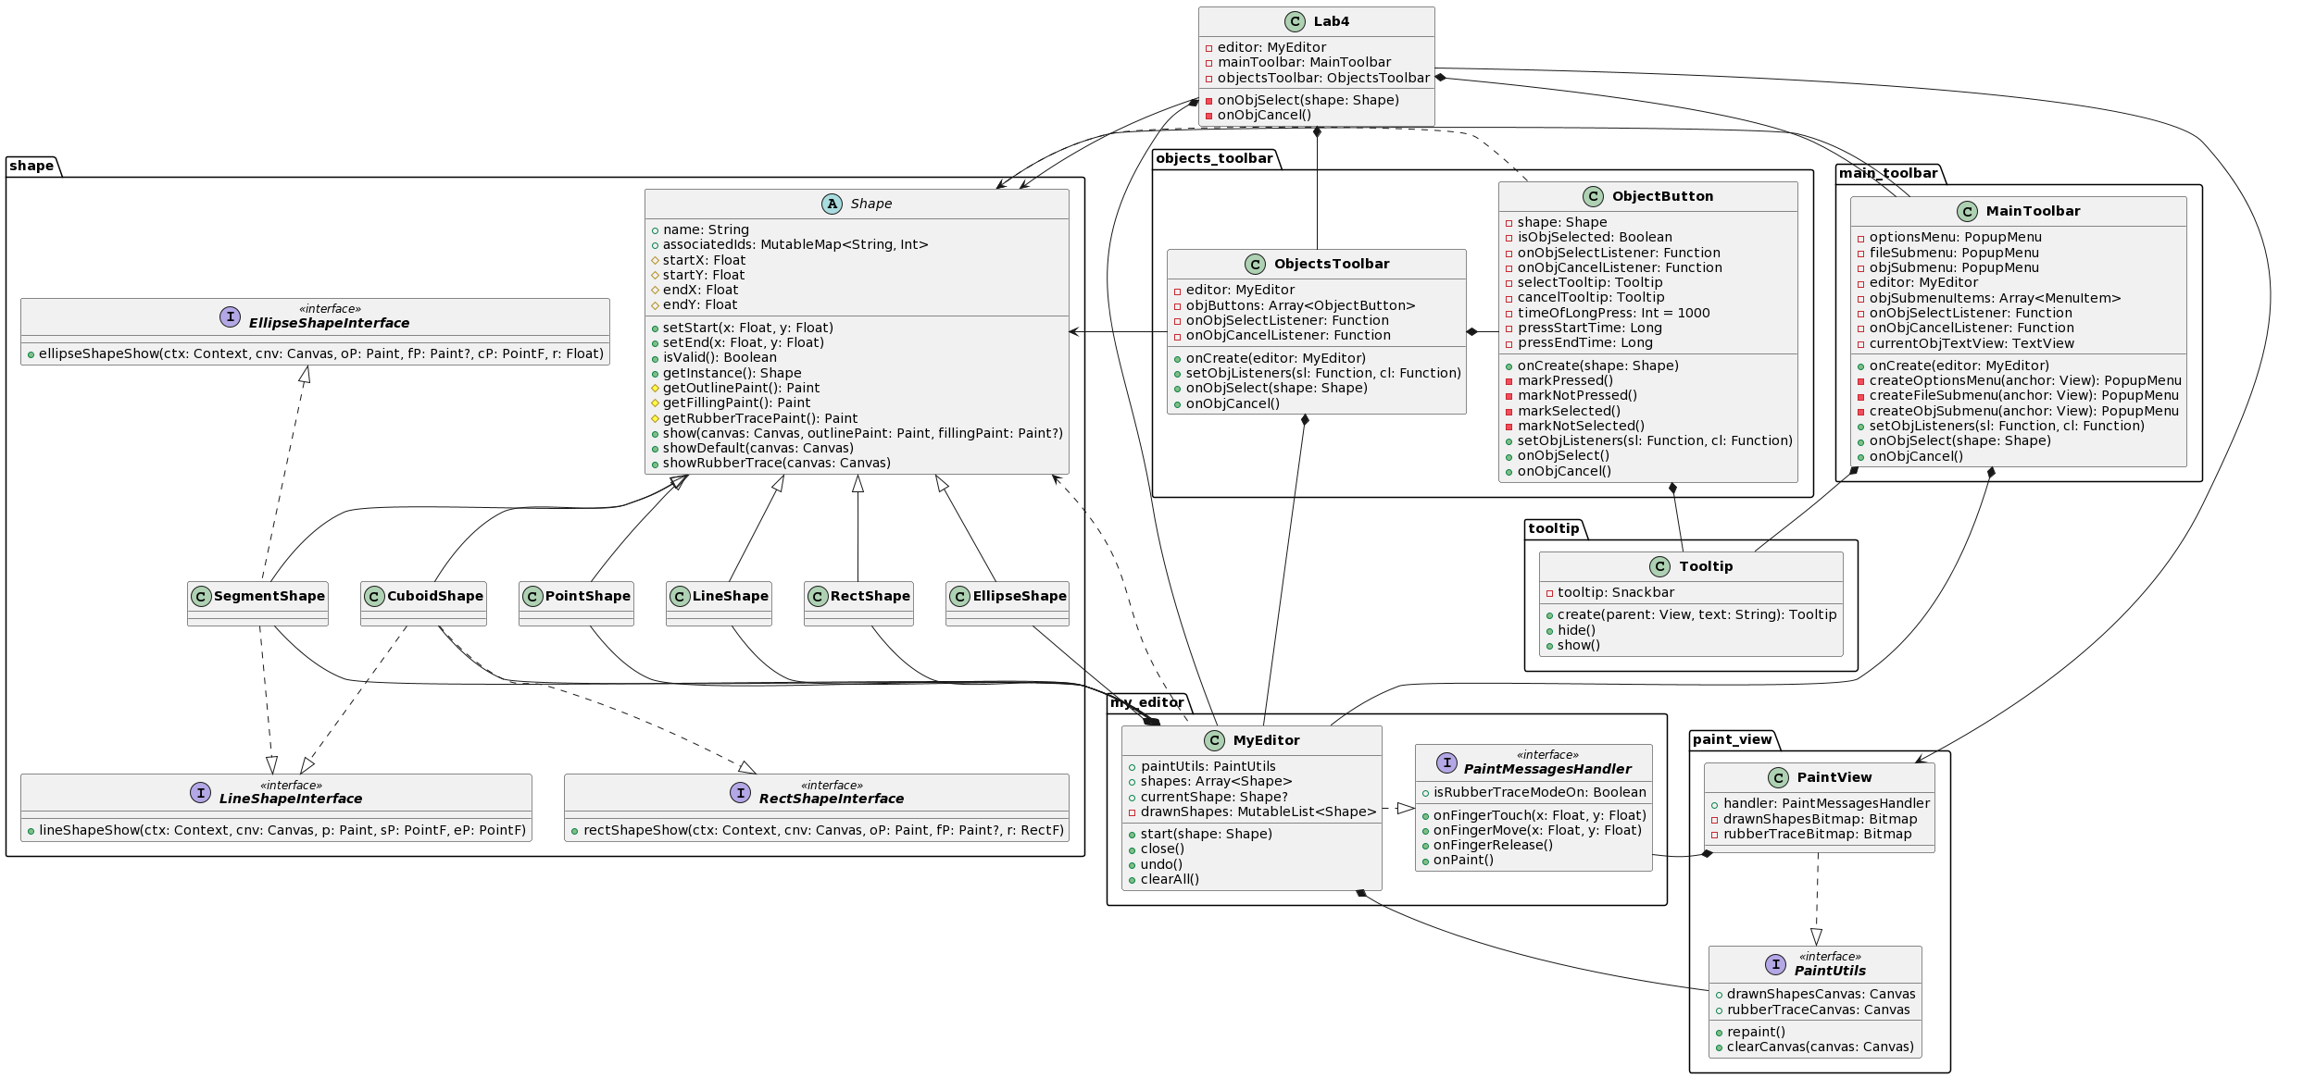

**Ілюстрації виконання програми**

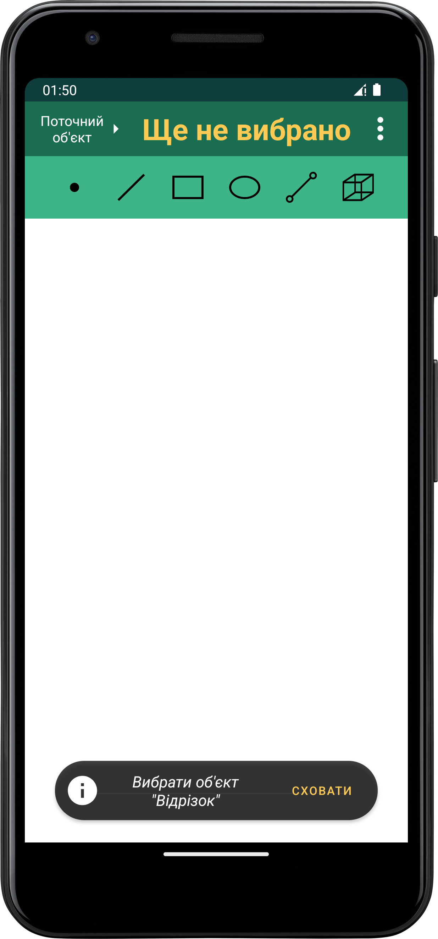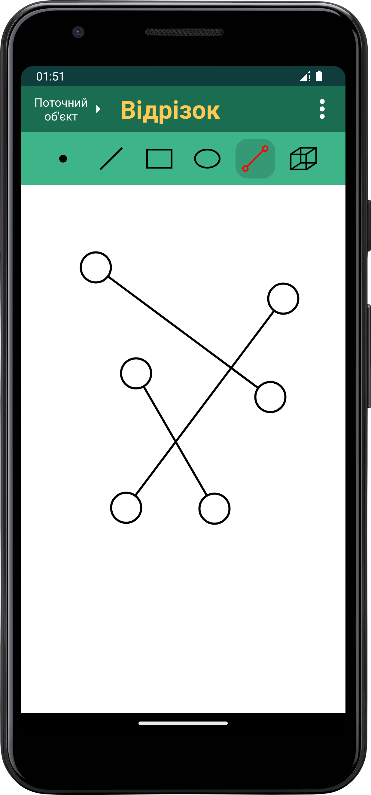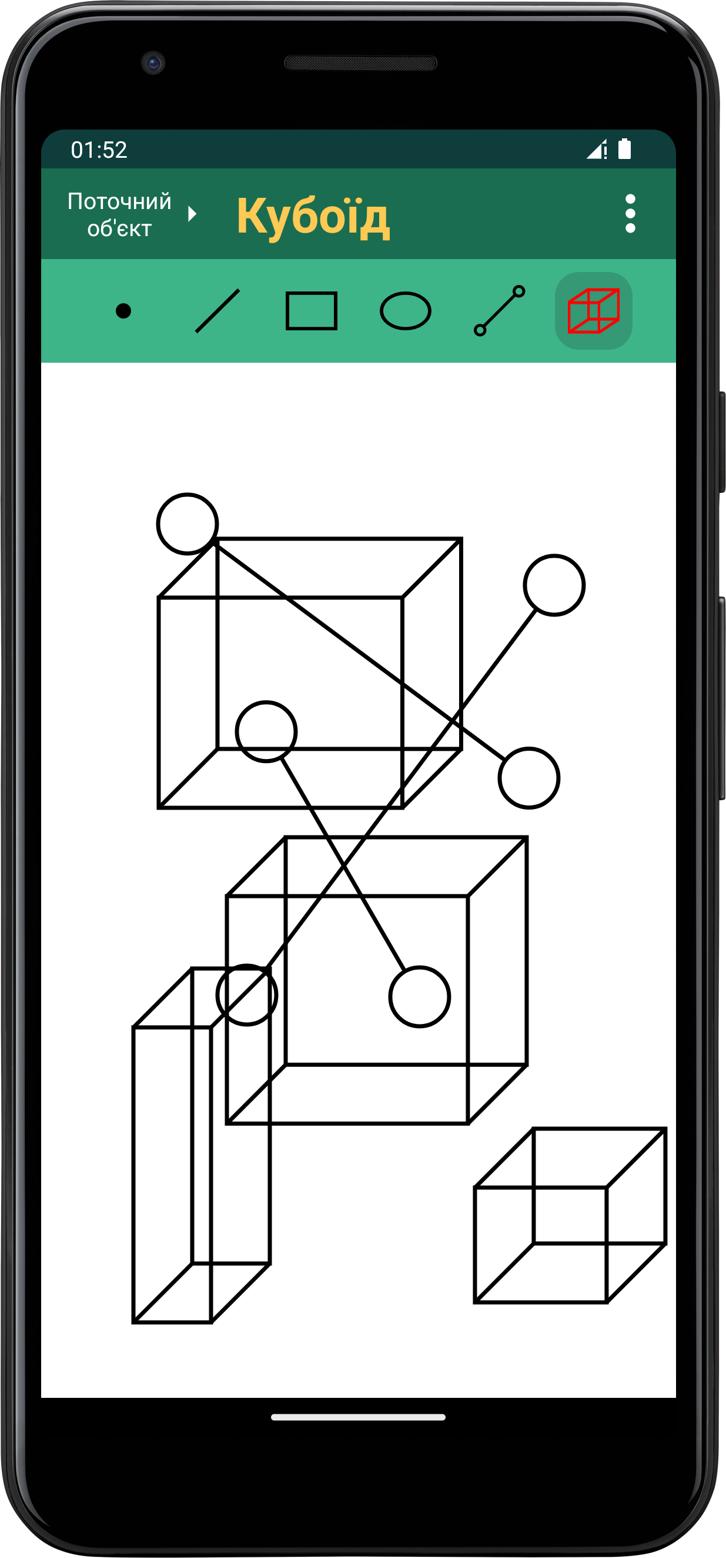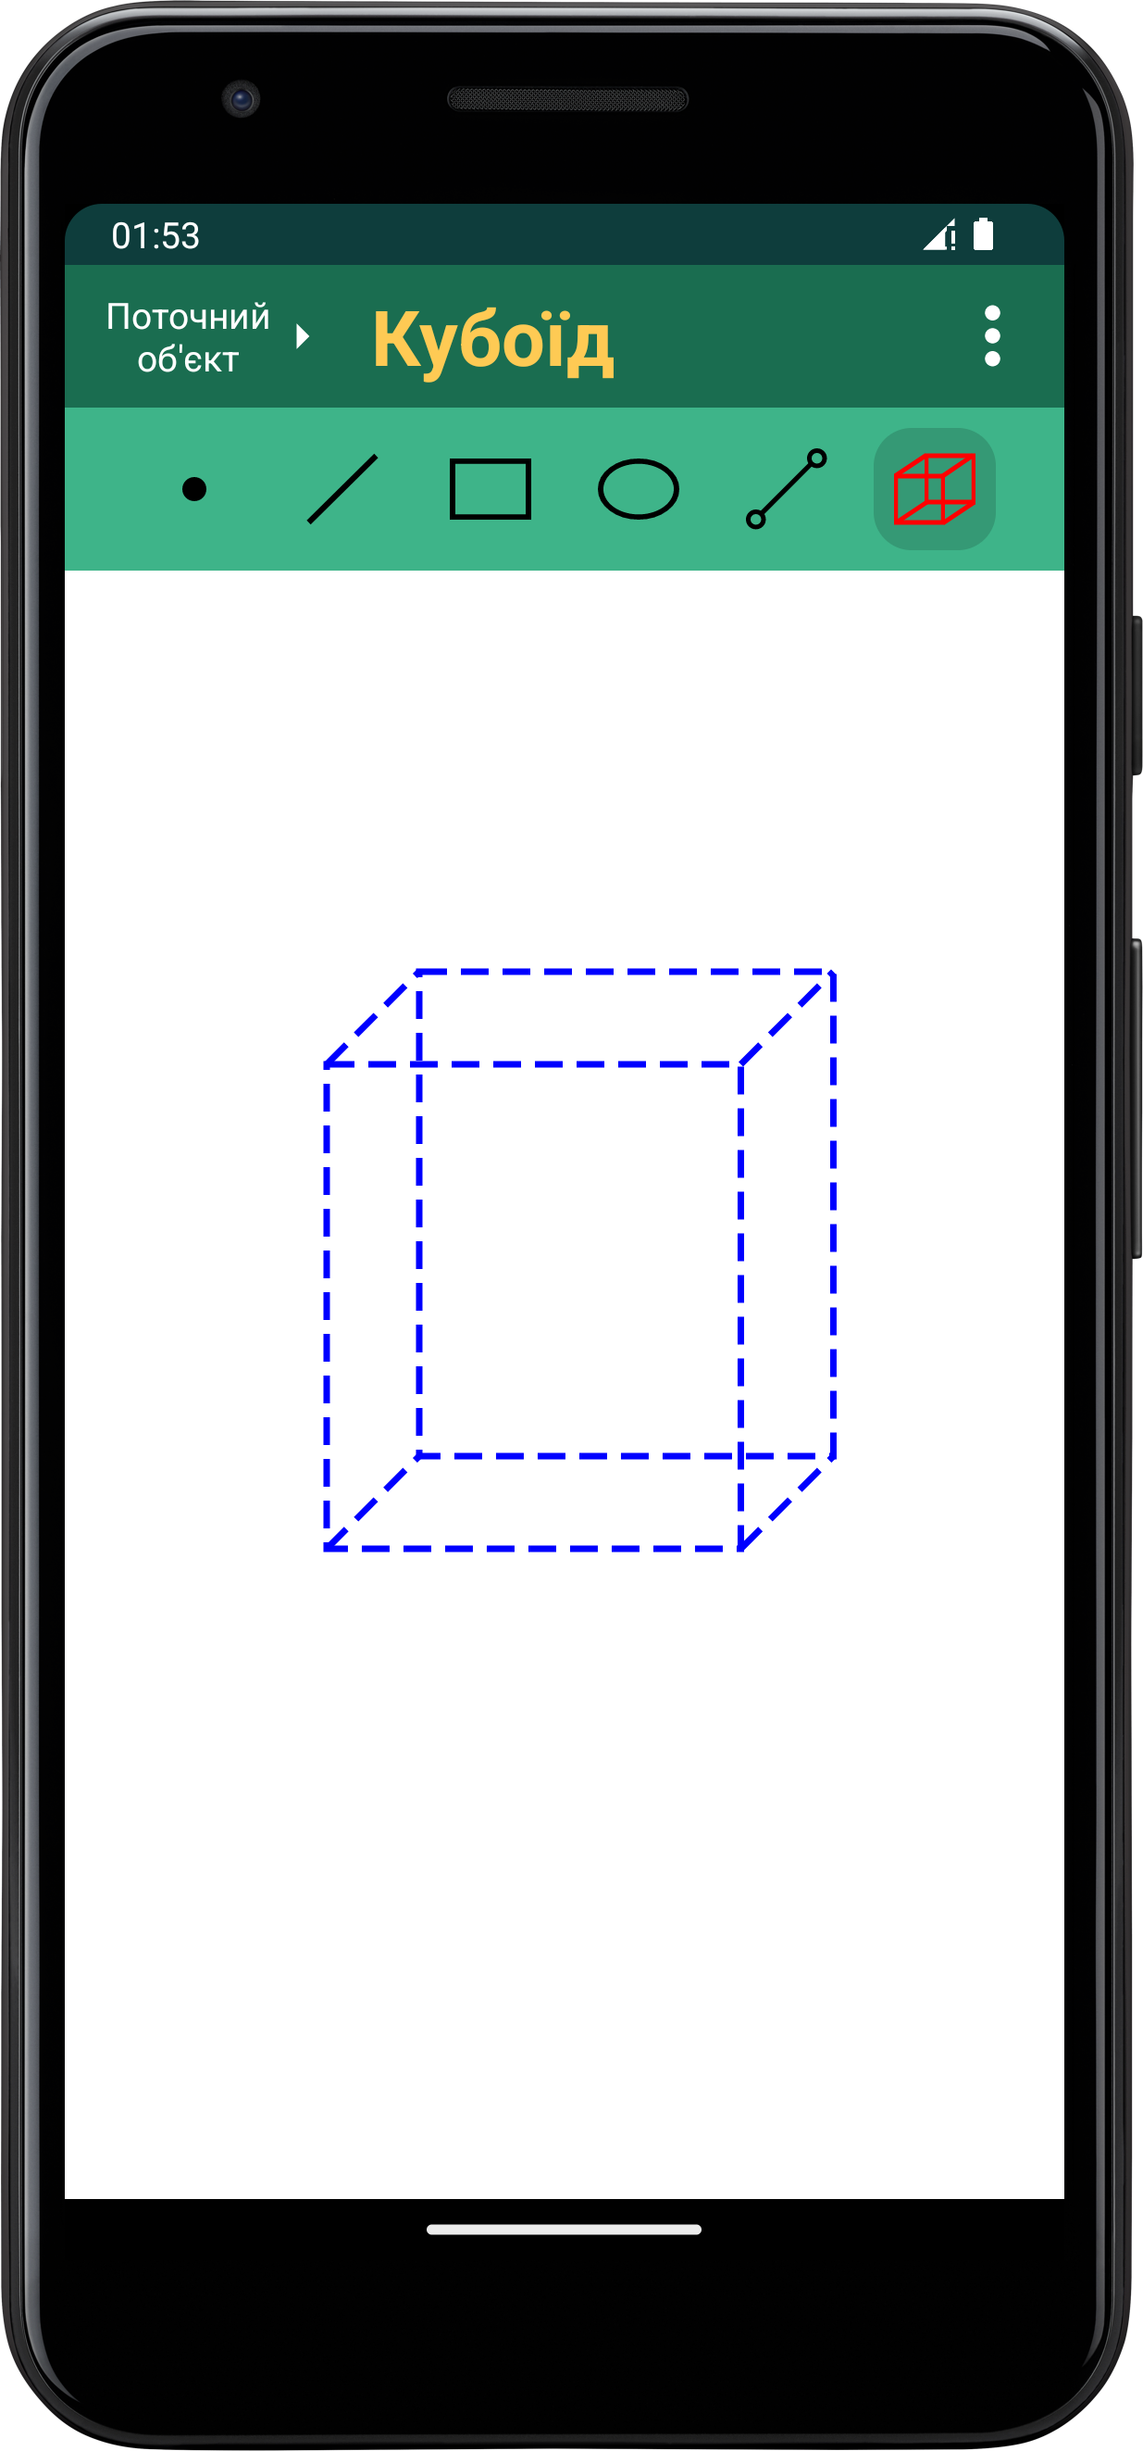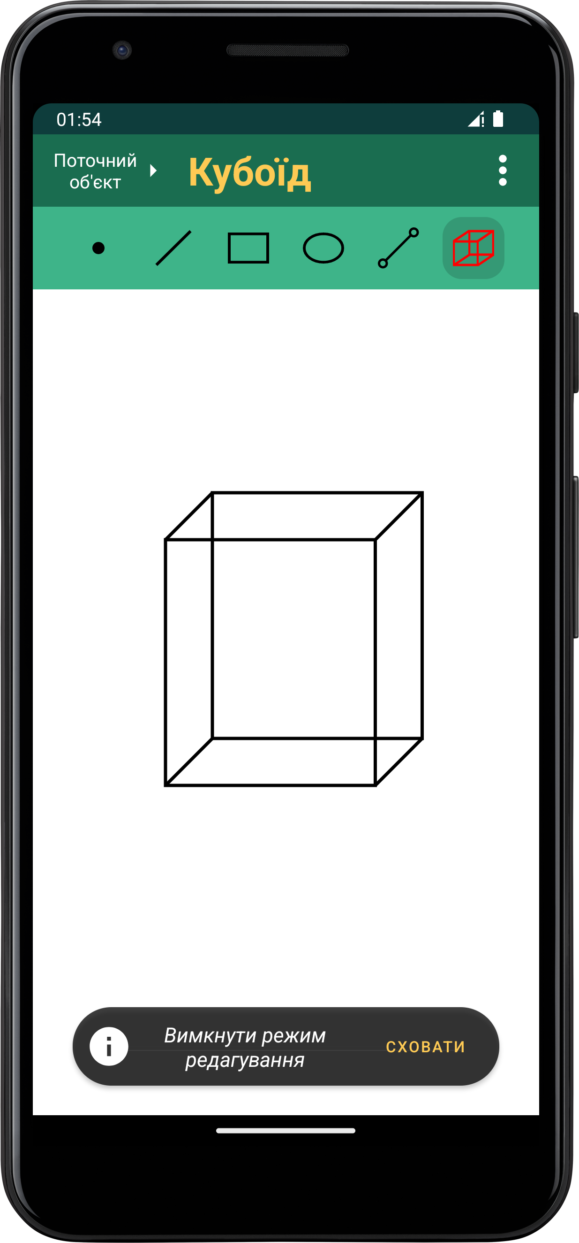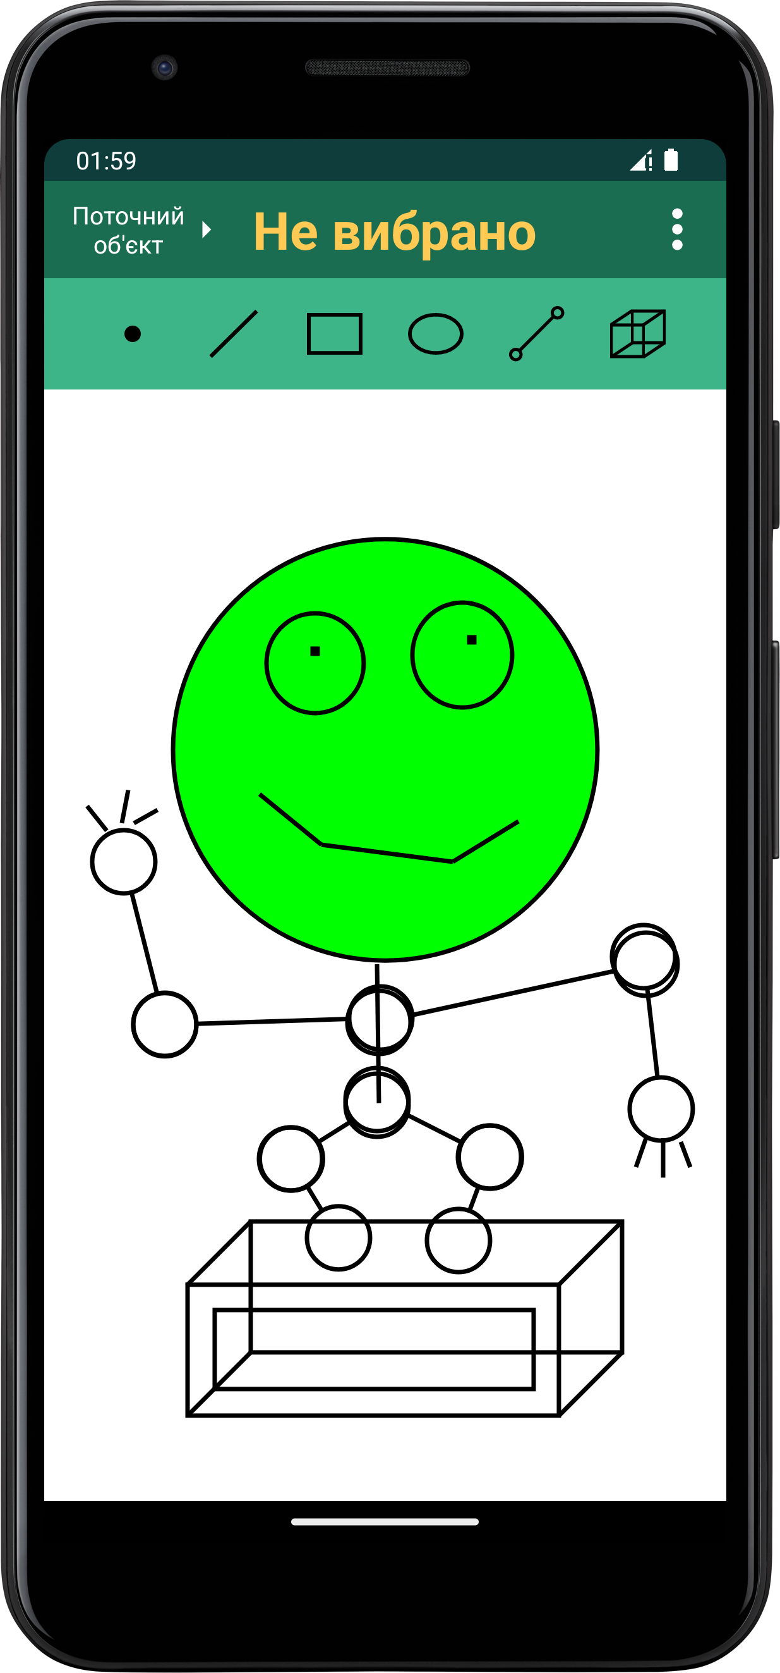

**Висновки**

Під час виконання цієї лабораторної роботи я удосконалив код раніше створеного графічного редактора для платформи ***Android*** за допомогою шаблонів та практик об’єктно-орієнтованого програмування. Внесені зміни забезпечать зручне додавання нових типів об’єктів. Наочним доказом цього слугують уже додані об’єкти *“Відрізок”* та *“Кубоїд”*. Це стало можливим завдяки об’єднанню усіх редакторів об’єктів в один клас ***MyEditor.***